*The Albert Schweitzer Familienwerk*

*Foundation Philippines, Inc. (ASFFPI) accepts*

*foreign and local volunteers who wish to help*

*the foundation staff in the implementation of*

*programs, projects and activities geared*

*towards the welfare and development of*

*disadvantaged children and youth under the*

*care and custody of its Children’s Haven for a*

*period of one month to one year.*

**2.** Houseparents shall be given copies of the planned/ agreed activities so that they could give full support for their implementation;

**3.** Film showing/movies shall be done only on Friday and Saturday evenings. However, if there are classes on Saturdays (in lieu of holidays during working days) film showing can be done only on Saturday evenings.

**4.** Besides group activities, volunteers/ interns are requested to help in tutoring/ identified children when they arrive at the center from their schools. Thus, each volunteer shall select as to who are the kids who shall be under him/her for tutoring.

**5.** Group activities shall be undertaken on weekends and shall not be in conflict with “Outreach” programs of donors/ benefactors and other groups.

**C. Out-of-Center activities:**

**1.** Volunteers/ interns could plan and conduct activities like camping, beach party, inter-group sports competition only on weekends.

**2.** For out-of-center activities, the volunteers/ interns shall have to generate resources besides lunch, like AM and PM snacks, payment for the vehicle to conduct the kids from the center to the activity site and return to the center. Furthermore, materials and equipment to be used for said activities shall be provided by the volunteers/ interns, as the foundation has limited budget.

*For effective implementation of programs,*

*services and activities please be guided by the*

*following policies/guidelines:*

1. **General Policies:**
2. The volunteers and interns, in consultation with the ASFFPI Social Worker/ Executive Director shall prepare and submit his/her plan of activities within one week after arrival.
3. Volunteers or interns shall render at least 32 hours a week duty.
4. Prior authority shall be requested from the SW/ED if another volunteer/ visitor will stay for the night or join an activity in the center participated in by ASFFPI kids.
5. No male visitors shall be allowed to enter the female bedrooms
6. Volunteer(s) accommodated in the center shall inform the staff if going – out of the center, about his/her destination, expected time of return or if not returning to the center in the evening.
7. Volunteers/ interns shall be models of good moral character to the kids.
8. For Dress Code:

* Not very short, shorts
* No plunging necklines
* No see-through blouses/ dress

1. In providing snacks / food with drinks, (Cola drinks and salty food (junk foods) are not allowed.

**B. Center – Based activities:**

**1.** Volunteers and Interns shall jointly prepare their program of activities/ services in consultation with the social worker;

**3.** Volunteers/ interns shall coordinate with the Social Worker for the preparation of “Pass slip” for the kids who are participating in out-of-center activities.

**4.** If the use of the Van is requested, the volunteers/ interns shall provide the gasoline and gear oil and payment for the services of the driver as the foundation has only one driver.

**5.** Payment of entrance fees in beach resorts shall also be shouldered by the volunteers/ interns.

**D. Privileges of Volunteers & Interns:**

**1.** Two days day-off

(suggested to be availed on week days instead of week-ends). However, this can be arranged.

**2.** Use internet connection (Wi-fi connected)

**3.** Use of computer/ laptop if the same is not used by the staff or kids.

**4.** Use of tables and chairs/ LCD projector for film showing

**5.** Free use of beddings, pillows and bath towels for those staying in the center.

**E. Obligations:**

**1.** Cash donation of not less than **PHP900.00** per day for lodging and simple meals.

**2.** Financial contribution and materials for activities to be conducted as included in their plans of activities.

**3.** Short report upon completion of the volunteer/ internship period.

4. Shall not delve into the past experiences of the children, especially on their traumatic experiences. If the kids volunteer to give information, it should be taken as a confidential information.

5. If they encounter problems in the implementation of activities, they have to consult the Social Worker.

**For those staying in the center:**

* Unless already familiar, they should request for a direction from the center staff if going to the city or other areas.
* Shall inform the center social worker/ officer on - duty if not feeling well or needs hospitalization/ treatment
* If they need anything, they should tell the Social Worker or houseparent

**For those leaving outside of the center:**

If absent, please inform the center Head/ Officer on – duty, when sick or cannot report for a day or more.



**Albert Schweitzer Familienwerk Foundation**

**Philippines, Inc. (ASFFPI)**

***Regional Winner***

***2007 National Search for Outstanding***

***Volunteer sponsored by PNVSCA***

**POLICIES AND GUIDELINES ON INTERNSHIP**

**AND VOLUNTEER PROGRAM**

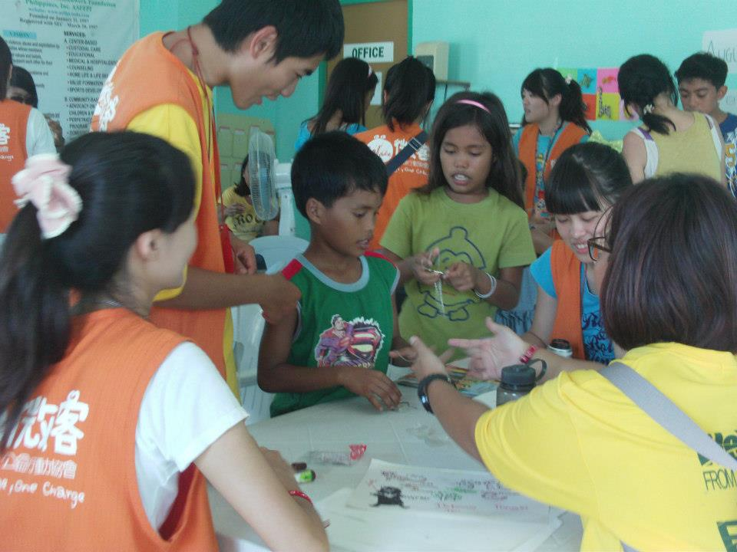

**Pilipog, Cordova, Cebu 6017 Philippines**

[www.asffpi.webs.com](http://www.asffpi.webs.com)

[asffpi_cebu@yahoo.com](mailto:asffpi_cebu@yahoo.com)

Telephone No. (006332) 496-7608

***Application Form: (please copy the form and***

***send it to ASFFPI thru email:*** [***asffpi_cebu@yahoo.com***](mailto:asffpi_cebu@yahoo.com)

Name: ___________________________________

Address: ________________________________

Email Address: ___________________________

Date of Birth: ____________________________

Present Age ______________________________

Experience in working with children:

_________________________________________

_________________________________________

Inclusive date: ______________________

Agency & Location: _________________________

Educational Attainment _____________________

Skills: _______________________________________

______________________________________________

Purpose for Volunteering:

___________________________________________

___________________________________________

___________________________________________

**Fluency in English (pls. check):**

Very fluent ______ fluent ______

Very good _______ good _______

Fare_____

**Inclusive dates for Volunteer work:**

_____________________________________

Signature: _____________________

Date signed: ____________________

***Contact us for further details:***

**Martiniana D. Mercado, RSW**

Executive Director

Mobile No: +639284038695/ +639171403428

**Ligaya V. Maquiling, RSW**

Deputy Executive Director

Mobile No: +639321013216

Email: [asffpi_cebu@yahoo.com](mailto:asffpi_cebu@yahoo.com)